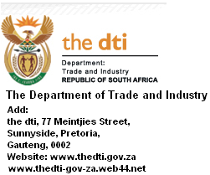

For your urgent attention:
Please treat as a matter of urgency.

I wish to contact you today to inform you of a very profitable project, which I needed, both of us to handle together as partners. My name is Mr. David Williams October; I am the Director General of Trade and Industry here in the Republic of South Africa.

As a matter of fact, this project is specifically a DEAL, which I arranged through my position in the Government during one of the contract that was awarded to a UK company in 2011.

My major reason for contacting you is that with the stand of the project, it will require a foreign partner to handle the project with me to its completion, so that we share the fund among us. During the course of the project, I will link you up with our Government as the foreign partner to the original contractor who will be receiving the unpaid balance contract amount from the Government and this balance contract amount will be send into your foreign bank account by the South African Government.

The project is a very profitable one, and I will need your commitment, honesty, transparency and trust, you will also be required to provide us with the following;

- Bank account that will be able to accommodate the cash sum of £17,850,000.00 or its equivalent in US Dollar, which is the balance contract amount involved on the project.

- You have to be able to bring out your time to follow up the project and also ensure that you communicate directly with the payer, which is our Government since it is a legal project and it will be handled by the Government itself, under my directive from this end as I am also the key personnel on the Government who will initiate the payment of the fund into your bank account.

This is a project that if we work together for the progress and complete it together successfully it will boost us financially and through this project you will as well have the opportunity to proceed with other projects with our Government through my connections.

Please note that this project is 100% LEGAL and if you are interested on this proposition, then you should revert back by sending me an email to notify me of your interest so that I will be able to give you more information on the processes for your understanding, and then we commence with the follow up. You can as well drop your direct telephone (Mobile) number so that I can call you to explain more in details, or you can give me a call for a faster communication.

I will be waiting to hear from you in due course.

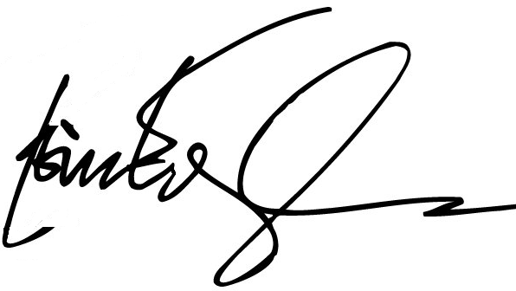
Regards,

Name: Mr. David Williams October
Position: Director - General
Department of Trade and Industry (dti)
Republic of South Africa
Official Email: mr.davidwilliams06@gala.net
Website: www.thedti-co-za.site11.com
www.thedti.gov.za
Profile: http://www.thedti.gov.za/about_dti/dg.jsp

