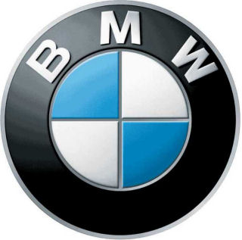
From BMW Automobile Company UK London.
22 Garden Close, Stamford Lane
Unit6 PE9 2YP London,
United Kingdom.

BMW Premium Selection
Your e-mail address has been randomly selected through e-mail balloting system power by
The internet on this year International Awareness Promotion. You have won 750,000.00 GBP (Seven Hundred and Fifty Thousand Great British Pounds) and a brand new BMW 5 Series, M Sport Saloon car. Congratulation! Congratulation!! Congratulation!!!

Contact DR. JOHNSON PIKER (fiduciary Manager) for your collection on e-mail: bmwclaimsdept2010@live.co.uk (+44) 7017515870) with full details entail your particulars immediately.

1. Full Names:
2. Residential Address:
3. Direct Phone No:
4. Fax Number
5. Occupation:
6. Sex:
7. Age:
8. Nationality:
9. Annual Income:
10. Won Before:

This is an online valid E-mail ID Promotion which is done once a year to eradicate poverty
And promote our new product.

Sincerely,
Mrs. Alice Graig
BMW M sport Promotion Team
For proper confirmation of your winning, kindly call this number immediately (+44 7017515868)
