
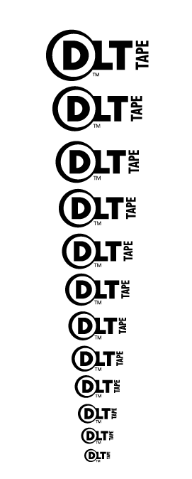

PRICE POINTS STARTING AT:
EXABYTE 8MM 170ME TAPE (STOCK) $50
DLT 20/40GB TK88 MAXELL $50*
*call for other brands!!!!
DLT 15/30GB TK85XT $26.96
DLT 10/20GB TK85 $24.96
DLT 8000 EXT’L SE SUBSYSTEM $2699
QUANTUM DLT 4700 TAPE MAGAZINE $69!!!!!
SONY AIT II INT’L LVD FACTORY REFURB $1699
FUJI LTO TAPE MEDIA $115
QUANTUM SUPERDLT TAPE MEDIA $119
HP LTO MECHANISMS AVAILABLE!!!!!!!! CALL!!!
DIRECT PRICING ON OVERLAND DATA DLT/AIT LIBRARY!!!

FUJI 4MM CLEANER 1200 $4.95
4MM 125M DAT UNLIMITED $7.95
FUJI 4MM 150M DAT UNLIMITED $19.50
FUJI 100MB ZIP MAC UNLIMITED $7.14
IOMEGA 100MB ZIP MAC/PC UNLIMITED $6.75
MAXELL 100MB ZIP PC 3500 $6.95
MAXELL 4MM 90M DAT 800 $CALL
SONY 8MM 112M TAPE 1200 $2.49
IMATION 8MM 112M TAPE 100 $2.49
IMATION BULK 8MM 160M TAPE 1500 $4.95
SONY AIT II 50C IN STOCK!!!! 400 $69.96
SONY AIT I W/CHIP 25C 500 $45
SONY AIT I 35C 200 CALL
SONY AIT II 36GB ***IN STOCK*** 350 $58
SONY 5.25 1.2GB OPTI BRANDED 1200 $19.95
IOMEGA JAZ 1GB 200 $69.95
IOMEGA JAZ 2GB 200 $72
SONY 3.5 HD F DISKS BRANDED UNLIMITED $.21
FUJITSU 1.3GB 3.5” OPTICALS 300 $15
IBM 5.2GB WORM 59H4789 1000 OFFERS
SONY QTR4/NS8 TAPE 400 $16.49
IMATION PD650 PHASE CHANGE OPTICAL 500 $15
SONY QD6150 ¼” TAPE 300 $5
SONY DC300XLP TAPE ¼” 0000 $5.95
IMATION NS20GB 1200 OFFERS
GENERIC 74MIN CDR MEDIA JEWEL/RETAIL UNLIM $.45
GENERIC 74MIN CDR MEDIA BULK UNLIM $.39
GENERIC DVD RAM 5.2GB MEDIA UNLIM $15
IMATION 650MB PHASE CHANGE 800 $19.95
TDK DVD-R 4.7GB MEDIA 500 $24.25
SONY 74MIN CDR MEDIA 12X W/JEWEL UNLIM $.49
NEED YOUR DRIVE REPAIRED???
FULL LINE OF ALL MEDIA AND STORAGE MECHANISMS!!!!!!!!!!!!!!
DON’T SEE IT, CALL NOW!!!!
PLEASE CALL FOR VOLUME DISCOUNTS!!!!!

Toll Free: 800.334.(data) 3282
OR
www.9to5computer.com

