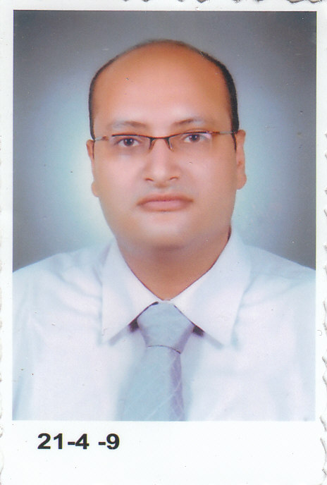
Fady GAMIL MARZOUK
Telephone: (002) 23167906
Mobile(002) 0121947042
E-mail: fady.accountant@yahoo.com
OBJECTIVE
 |  | Seeking a challenging position in a big and famous organization where I can develop my skills and enrich my experience; and at the same time become a great benefit to the organization.
EDUCATION
1999-2002  2007-2008 |  | - Bachelor of Commerce, Accounting Department, Cairo University, with Grade good.  - Diploma in Accounting and Auditing with grade very good from Cairo University.  - Chartered Accountant.
SKILLS
Computer Skills:
- Excellent knowledge of MS Windows.
- Excellent knowledge of the Internet.
- Excellent Knowledge of MS Office.
- ICDL Certification.
Language skills:
- Native language Arabic.
- Excellent command of written and spoken English.
Experiences
2003-2005  Responsibilities  2005-2008  Responsibilities  2008-2011  Responsibilities |  | Mohamed Moawed office.  - Establishing and altering companies with all legal sorts (law 8 and law 159) and so all their legal entities (individual establishments – individual companies – financial companies)  - Organizing accounting records and preparing tax files for being inspected.  - Preparing all sorts of financial statements (balance sheet- income statement- cash flow statement- statement of changes in equity) according to the Egyptian accounting standards.  Magdy Sadk office  - Reviewing all accounting records and tax and financial statements in accordance with Egyptian auditing standards.  - Organizing and preparing tax returns on income-tax - the sales tax - income tax – stamp tax  Samy Merry office  - Regulate the movement of costs and financial restructuring and preparing budgets  - Organization of CAS in respect of contracting companies  - Dealing with commercial banks in all transactions for letters of guarantee- and documentary credits- foreign remittances.  - Dealing with incoming and outgoing messages starting from the extraction of import and export cards and bills documentation, and organizing all shipment papers and tracking clearance companies to control the cost movement of customs, fees and expenses of clearing the ending with the` organization of the papers of the overall charge from the customs for the purposes of tax inspection
PERSONAL INFORMATION
Nationality : Egyptian
Date of Birth: 13/11/1981
Marital Status: Single
Military Status: Exemption

